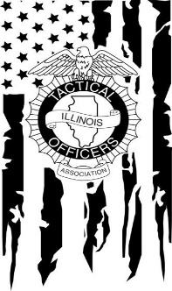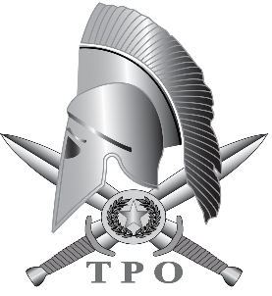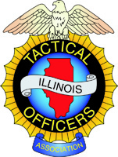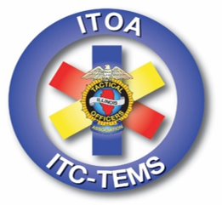
ITOA Tactical Training

The Illinois Tactical Officers Association offers a wide variety of Patrol & SWAT training. Classes are taught in your area, by State Certified, ITOA Subject Matter Experts at a very reasonable cost.

Course Info: Each listed course can be offered at the basic or advance end user level and some can be offered to obtain instructor certification. The listed courses are generic subjects, each course can be modified to meet the training goals and objectives of the host agency. Each course can be conducted for your department independently, or offered as an “open” course for the law enforcement officers and EMS / Fire personnel in your area.

Host Agency Benefits: Host agency receives 1-2 complimentary spots in each class; the convenience of the course being held in your area and the opportunity for your instructors to join the ITOA SME’s and obtain instructor development free of charge.

Membership: Individual Officers must be ITOA members to attend ITOA course. This does not apply when Department’s contract with ITOA to provide training for their department.

Registration: The ITOA has a professional support staff that facilitates the on-line registration and payment requirements.

Courses Offered:
- 2 Week Basic SWAT Course
- 3-5 Day Advance SWAT Courses
  - Hostage Rescue
  - Warrant Service
  - Barricaded Gunman
- Extended Range, Kinetic Energy Impact Munitions Certification (12 Gauge & 37mm/40mm)
- NFDD Certification
- Tactical Pistol & Rifle Courses
- Shoot House Instructor Course (Sponsored & Certified by CSAT – Combat Shooting & Tactics)
- Rapid Deployment - Active Threat Response
- Immediate Trauma Care (Sponsored & Certified by the BECON Group)
- Solo Officer Response to an Active Threat
- Urban Tactics - MACTAC
- Rescue Task Force
- Stop the Bleed
- High Risk Patrol Tactics: Building Searches – Arrest Team Tactics – High Risk Vehicle Stops
- Realistic Scenario Based Training
- Live Fire Shoot House – Illinois & Out of State Sites
- Active Threat Live Fire Skill Sets
- High Risk Operational Command & Control for Police & Fire
- Functional Exercise Development – Planning – Safety – Control – Coordination
POC: For more information and/or to receive an ITOA proposal for your agencies training needs, contact ITOA Director of Training Chief Ed Mohn: emohn@itoa.org Cell: 262-945-9892

